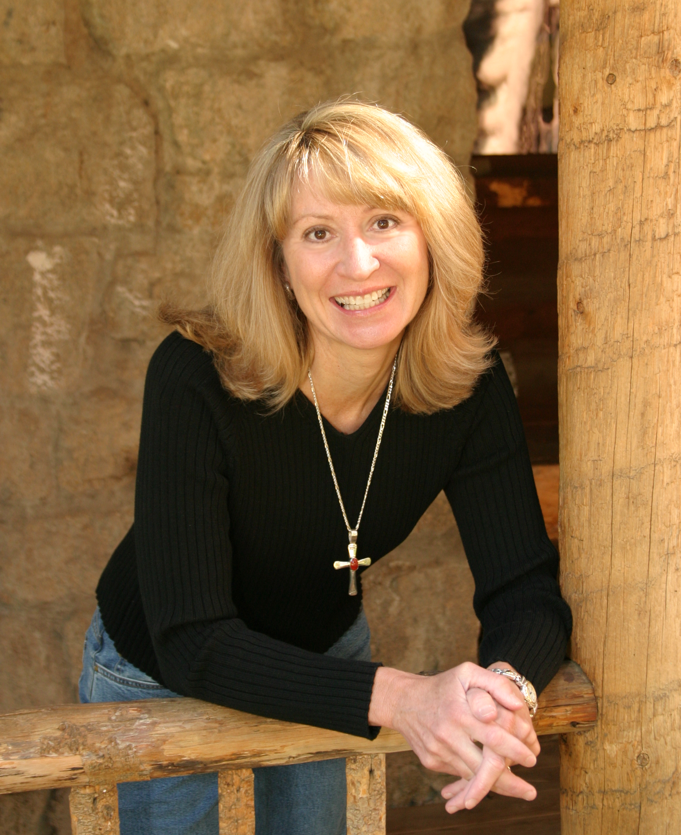
Sherri Farmer - In Concert
June 6, 2010
11:00 am & 6:00 pm (full concert)

Rapid Valley Baptist Church
3450 School Dr., Rapid City, SD

Info: 605-393-1375 sherrifarmer.com

